**Data Driven Agility Hotel information**

Please contact the hotels to CONFIRM their pet policies.  
Hotel Courtesies: All poop is to be picked up. Bring a sheet to cover your bed., Bring a towel to place under the water bowl and to dry your dogs if needed.  
DO NOT LEAVE YOUR DOG ALONE IN THE ROOM AT ANY TIME

**Other options**

[**https://www.airbnb.com/**](https://www.airbnb.com/)

[**https://www.vrbo.com/**](https://www.vrbo.com/)

**Holiday Inn Express** 818 Charlestown Rd Springfield VT

(866)-573-4235

**Rodeway Inn** 593 Rockingham Rd Bellows Falls VT

(866)-573-4235

**Sunapee Lake Lodge** 1403 Route 103 Newbury VT

(866)-925-4159

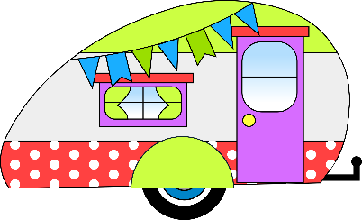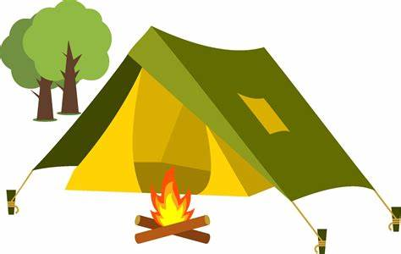**Please note that there are limited**

**RV (5-8 depending on size)**

**& tent spots   
 (all dry camping) at DDA  
They will be reserved 1st received.**  **You can reserve by contacting Val at K9AS@comcast.net**